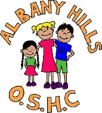
. ALBANY HILLS
State School P&C
Outside School Hours Care
NEWSLETTER
July 2022

Vacation Care

Vacation Care Bookings for the September Holidays will open Monday 5th September.

We will email all families with a copy of the vacation care program.

Ensure all forms emailed are signed and attached in pdf format. We are unable to process photos of forms or complete bookings without all signed documentation.

If you have an outstanding account in arrears vacation care bookings will not be accepted until your account is in line with our debt policy and no more than 7 days in arrears.

Please note that forms are processed in order of receipt and at times some days do book out within hours. We understand the difficulty and stress this can cause families however we do our best to accommodate all family needs.

New OSH Building

We have now settled into the new building and sorted out any transition and operational issues we had within the first couple of weeks.
Children are more settled and not as excited as they were in the first couple of weeks.

It is amazing how we used to all fit into the old building on reflection.

We hope that all the families are enjoying the new facilities as much as we are and welcome any feedback to enhance and improve the facilities you may have.

Don’t forget you are all welcome to come into the building and have a look around and join your children in the activities provided or simply just play.

Program and Practices Survey

Last week I emailed out a survey to all famlies to ask for feedback on our service’s practices and program.

If you have a spare five minutes please take the time to give us your valuable feedback. This will help us to identify areas that may need improvement. It will also enable us to reflect upon our practices and see what we do well and what you and the children enjoy about OSH.
Use the link below to complete the survey:

OSH Practices and Program Survey 2022

OSH BOOKINGS AND CANCELLATIONS

A reminder that all bookings and cancellations must be completed in writing. Please do not ring and make bookings and cancellations over the phone.

Bookings and cancellations can be done either by email to:

oshc@albanyhillspandc.org.au

or in the Bookings and Cancellation folder on the sign in desk at the service.

The following cancellations times apply for no charge of sessions:

Before Care Bookings – cancel booking by 6PM night before booking for care.

After Care Bookings – cancel booking by 9AM morning of aftercare booking.

Can we request, if possible, any changes for the coming week be emailed through before 5 pm on the Friday of the previous week.

This will enable us to have the rolls up to date and correct for printing for coming week and check adequate staffing is rostered.

When emailing bookings and cancellations to can you include the following information:

- Name the session type (Before or After) you are amending.
- If you are booking or cancelling or making a permanent change.
- Name of child/ren you are booking or cancelling and the class they are in.

Up Coming EVENTS:

Disney: The Magic of Animation Exhibition

Walt Disney. It is a name that is synonymous with world-class animation and much-loved children’s classics. And now, the drawings, artwork, sketches, and behind-the-scenes works of nearly 30 Disney favourites has arrived in Brisbane, as Queensland Museum launches their Disney: The Magic of Animation exhibition.

Aside from the sketch boards and stools that the kids can use throughout the exhibition, there are also a lot of other fun highlights for children.

The Queensland Museum have created a dedicated Children’s Trail of facts, questions, and imaging for kids at each of the main displays.


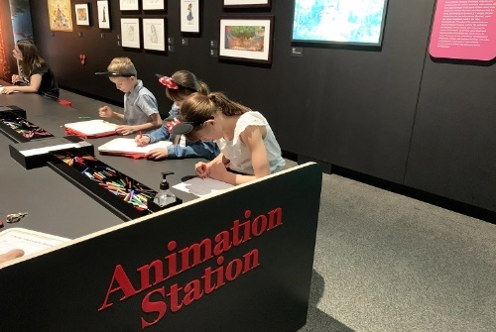

Breakfast finishes at 7.45am.

We need to close breakfast right on 7.45am. No orders after this time will be taken.

If you arrive after this time, we are unable to serve children breakfast.

Please understand we need to clean up after breakfast and organize the children ready for the school transition.

We do have a fruit bowl available for children to always access if they are hungry.

Cooler Weather

As the mornings and evenings are getting quite cool, we ask that parents please supply children with suitable winter uniform whilst at OSH.


We are required under regulations to ensure children are comfortably dressed according to the weather / season. We also have many children that attend with conditions like asthma. We want to ensure that children are cared for as they would be at home, and they are dressed suitably for the weather especially when leaving the service if later at night when cold. This may include asking children to put their jumpers on if the weather turns cold.

Disney: The Magic of Animation is open now at the Queensland Museum and runs from 24 June 2022 – 22 January 2023.

Book tickets at https://disney.qm.qld.gov.au/
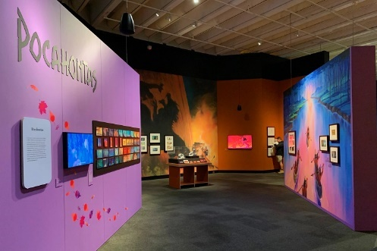

EKKA Show Holidays – Service Closure
OSH will be CLOSED
Monday 8th August for MBRC Public Holiday - Show Day.

OSH will be OPEN
Wednesday 10th August as per normal school day (BCC show day holiday).

Child Protection Training

As part of our ongoing professional development at OSH all educators participated in our annual ‘Child Protection Training’ last Tuesday night.

This is an integral training session completed each year for our educators to gain valuable knowledge of child protection. It enables our educators to understand what their ‘duty of care’ and responsibilities are being ‘mandatory reporters’.
The Child Protection Act 1999 requires certain professionals, referred to as ‘mandatory reporters’, to make a report to Child Safety, if they form a reasonable suspicion that a child has suffered, is suffering or is at an unacceptable risk of suffering significant harm caused by physical or sexual abuse, and may not have a parent able and willing to protect them.
Mandatory reporters should also report to Child Safety a reasonable suspicion that a child is in need of protection caused by any other form of abuse or neglect.
Under the Child Protection Act 1999, mandatory reporters are:
- teachers
- doctors
- registered nurses
- police officers with child protection responsibilities
- a person performing a child advocate function under the Public Guardian Act 2014
- early childhood education and care professionals, from 1 July 2017. ECEC professionals include staff from family day care, kindergarten, limited-hours care, long day care and after-school hours care. Individuals who are volunteers or under 18 years of age are not mandatory reporters.

Recipe of the Month

Ultra-Satisfying Chicken Noodle Soup

Source:

www.inspiredtaste.net/37475/homemade-chicken-noodle-soup-recipe/

YOU WILL NEED

2 tablespoons butter, chicken fat or olive oil
1 large onion, chopped
2 large carrots, chopped
2 stalks celery, chopped (optional)
Heaped tablespoon minced garlic (4 cloves)
2 bay leaves
3 sprigs fresh thyme or use 1/2 teaspoon dried thyme
4 or 5 skinless, boneless chicken thighs
8 cups chicken stock or broth, low sodium or use homemade stock
150 grams egg noodles (or pasta of choice)
Salt and pepper, to taste
1/4 cup fresh parsley, finely chopped
Water or more stock, as needed

DIRECTIONS

Melt butter in a large pot or Dutch oven over medium heat. Add the onions, carrots, and celery. Cook, stirring every few minutes until the vegetables begin to soften; 5 to 6 minutes.

Stir in the garlic, bay leaves, and thyme. Cook, while stirring the garlic around the pan, for about 1 minute.

Pour in the chicken stock and bring to a low simmer. Taste the soup then adjust the seasoning with salt and pepper. Depending on the stock used, you might need to add 1 or more teaspoons of salt.

Submerge the chicken thighs into the soup so that the broth covers them. Bring the soup back to a low simmer then partially cover the pot with a lid and cook, stirring a few times until the chicken thighs are cooked through; about 20 minutes.

If, during this time, the broth seems low, add a splash more stock or a bit of water. Turn the heat to medium-low.

Transfer the cooked chicken to a plate. Stir the noodles into the soup and cook until done, 6 to 10 minutes depending on the type of noodles used.

While the noodles cook, shred the chicken into strips or dice into cubes. Slide the chicken back into the pot and then taste the soup once more for seasoning. Adjust with more salt and pepper, as needed. Stir in the parsley and serve.


Positive Behaviour Plan
Recently Emily J spent many hours reviewing, researching, and updating our services, ‘Positive Behaviour Plan’.

I have pasted a copy below for families to read and understand the strategies we use at OSH when working with children and families to enable all children to participate in the OSH program in a positive and safe capacity.

We would love any feedback on the plan. If you have any questions or input please email them to oshc@albanyhillspandc.org.au

POSITIVE BEHAVIOUR PLAN
STATEMENT

Albany Hills Outside School Hours is committed to facilitating a care environment that is welcoming, safe, dynamic, and inclusive in nature. Working in partnership with our students, educators, and families to ensure the personal success of each and every student, children are given the opportunity to flourish in the presence of quality learning experiences and develop values that are supportive of their lifelong wellbeing. Recognising the importance of inclusive education and nurturing student’s development of social and emotional skills, our centre incorporates experiences in the curriculum that are designed to foster positive self-esteem, emotional regulation, confidence, and the building of resilience whilst also encouraging independence and autonomy.

In recognition of the school’s three overarching principles surrounding the promotion of positive behaviour, the children, and educators of Albany Hills Outside School Hours Care consistently strive to:
- Be kind
- Be safe
- Be respectful
We put our students first and believe in instilling learner qualities where they are called to be curious, self-motivated, a risk taker, persistent and reflective in nature. It is the centre’s expectation that our OSHC community of educators, parents and carers will support our Behaviour Support Plan and work collaboratively in making any necessary adjustments.

OUR BELIEFS

Behavioural support and the provision of inclusive education is a fundamental component of teaching occurring both inside the classroom and the OSHC environment. Fostered within an environment that is safe, positive, inclusive and productive in nature, our approach to behavioural support in incidences where behaviour becomes challenging is based upon principles of consistency, fairness and engagement. We recognise and embrace the rights of all children to access and participate in quality inclusive care. Providing opportunities for children to play, develop and learn collaboratively with children of all ages, we acknowledge and recognise that these forms of relationships established within our centre are foundations for lifelong learning and provide a powerful way of belonging and sense of self.

We value inclusive education within our centre by:
- Recognising the right of every child to participate meaningfully in all aspects of their schooling life
- Viewing children as being capable and valuable contributors as opposed to having deficits that need to be ‘fixed’
- Value diversity as a resource that informs all policy and practice
- Welcoming all children, families, and carers at the service
- Providing flexible programs and environments that meet individual needs and interests
- Continuing to build partnerships with families and the broader school community
- Working collaboratively
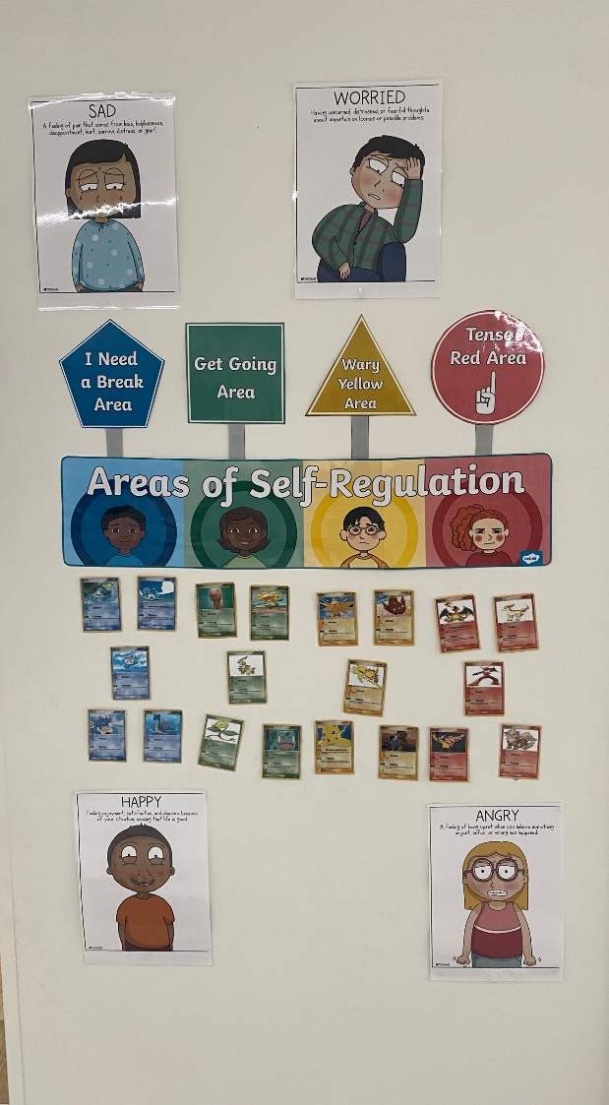
- Engaging in ongoing reflection and learning
- Ensuring parents and carers are aware of the provision of inclusive practices within the centre and are given the option to provide feedback

ZONES OF REGULATION

The Zones of Regulation is a complete social-emotional learning curriculum, created to teach children self-regulation and emotional control. This program teaches a variety of social-emotional skills to children, starting with early emotional skills and advancing on to self-regulation and navigating social situations. Some of the skills we encourage by implementing this program is:
- Identifying emotions – categorising feelings into four zones
- Self-regulation – achieving the preferred state of alertness (zone) for a situation
- Identifying triggers
- Coping strategies – techniques and strategies that help achieve emotional regulation and manage strong emotions
- Size of the problem – introduces the idea that the size of your reaction should match the size of your problem in conjunction with strategies for problem solving
- Expected behaviour vs unexpected behaviour – covers perspective taking and how your behaviour affects the thoughts and feelings of the people around you.
Figure 1: Areas of Self-Regulation Wall
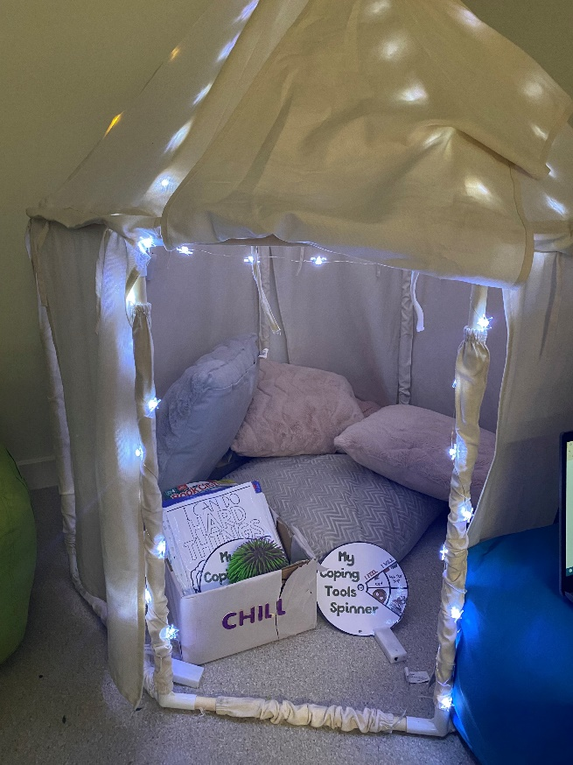
THE CALM CORNER

The calm corner is a dedicated, low sensory space that we offer within the centre, utilised by children who recognise that they need a moment to calm down. Staff members are encouraged to direct children to this space in the event that they need an enclosed, quiet space to self-regulate their emotions.

NATIONAL QUALITY STANDARDS

The National Quality Standard (NQS), operated by Albany Hills Outside School Hours Care, sets a high national benchmark for early childhood education and care and outside school hours care services in Australia and includes 7 quality areas that are important outcomes for children. Whilst all areas of the NQS shape the way in which we provide quality inclusive care to our children and families within
OSHC environment, the following quality areas are significant when looking through the lens of positive behavioural support.
Figure 2: The Calm Corner

Quality Area 5 – Relationships with children

Quality Area 5 under the National Quality Standard focuses specifically on promoting relationships with children that are not only responsive and respectful, but rather also promote a child’s sense of security and belonging within. Through the establishment of these relationships, children are free to explore the environment they are in and engage in meaningful play and learning.

Relationships with Children
Standard 5.1 | Relationships between educators and children | Respectful and equitable relationships are maintained with each child.
Element 5.1.1 | Positive educator to child interactions | Responsive and meaningful interactions build trusting relationships which engage and support each child to feel secure, confident, and included.
Element 5.1.2 | Dignity and rights of the child | The dignity and rights of every child are maintained.
Standard 5.2 | Relationships between children | Each child is supported to build and maintain sensitive and responsive relationships.
Element 5.2.1 | Collaborative learning | Children are supported to collaborate, learn from and help each other.
Element 5.2.2 | Self-regulation | Each child is supported to regulate their own behaviour, respond appropriately to the behaviour of others and communicate effectively to resolve conflict.

NATIONAL REGULATIONS

Regulation 155 – Interactions with children

Albany Hills State School Outside of School Hours Care takes reasonable steps to ensure that the education and care services provide education and care to children in a way that:

- Encourages the children to express themselves and their opinions; and
- Allows the children to undertake experiences that develop self-reliance and self-esteem; and
- Always maintains the dignity and rights of each child; and
- Gives each child positive guidance and encouragement toward acceptable behaviour; and
- Has regard to the family and cultural values, age, and physical and intellectual development and abilities of each child being educated and cared for by the service.

Regulation 156 – Relationships in groups

Albany Hills State School Outside of School Hours Care takes reasonable steps to ensure that the service provides children being educated and cared for by the service with opportunities to interact and develop respectful and positive relationships with each other and with staff members of, and volunteers at, the service.

MY TIME OUR PLACE

In school age care settings educators collaborate with children to provide play and leisure opportunities that are meaningful to children and support their wellbeing, learning and development. School aged care settings pay particular attention to the needs and interests of individual children within a context that promotes collaboration and active citizenship. Within these settings, children have choice and control over their learning as they collaborate with educators to extend their life skills and develop various dispositions of cooperation, confidence, curiosity, and reflexivity along the way.

The My Time our Place framework recognises the importance of social and emotional development and communication in learning through play and leisure and forms the foundation for ensuring that children in all school age care settings engage in quality experiences that challenge them to be curious about what is of interest to them while at the same time developing self-identity and social competencies.

Within the context of Positive Behaviour Support, the following is emphasised in our approach to care:

Learning Outcomes

Learning Outcome 1: Children have a strong sense of identity
  - Children feel safe, secure, and supported when our educators:
    - Spend time interacting and conversing with children, listening and responding sensitively as they express their ideas and needs
    - Support children’s attachment through consistent and warm nurturing relationships
    - Support children in times of change and bridge the gap between the familiar and the unfamiliar
    - Recognise that feelings of distress, fear or discomfort may take some time to resolve
    - Acknowledge each child’s uniqueness in positive ways
    - Support the development of children’s friendships
    - Acknowledge the importance of opportunities for children to relax through play and leisure.
  - Children develop their autonomy, inter-dependence, resilience, and sense of agency when our educators:
    - Encourage children to make choices and decisions
    - Provide children with strategies to make informed choices about their behaviours
    - Promote children’s sense of belonging, connectedness, and wellbeing
    - Mediate and assist children to negotiate their rights in relation to the rights of others

Learning Outcome 3: Children have a strong sense of wellbeing
- Children develop a sense of belonging to groups and communities and an understanding of the reciprocal rights and responsibilities necessary for active community participation when educators:
  - Promote a sense of community within the school age care setting
  - Provide opportunities for children to investigate ideas, complex concepts and ethical issues
  - Model language and actions that children can use to express ideas, negotiate roles and collaborate to achieve goals

Principles:
- Secure, respectful and reciprocal relationships
  - Supporting the development of a strong sense of wellbeing and social competencies, our educators are attuned to children’s thoughts and feelings within the centre. Exhibiting qualities of fairness, humour, sympathy and understanding, respectful and trusting relationships are ongoingly built with children, families, colleagues and other professionals within the OSHC setting. Our educators strive to foster independence and initiative thereby nurturing children’s agency and leadership skills.

Practices:
  - Holistic Approaches
    - In recognising the connectedness of mind, body and spirit, our educators at Albany Hills OSHC take a holistic approach to their roles and responsibilities
    - They focus attention on children’s physical, personal, social, emotional and spiritual wellbeing as well as cognitive aspects of learning as it pertains to lifelong learning.
    - Educators recognise the connections between children, families and communities and the importance of reciprocal relationships and partnerships.

    - They see learning as a social activity and value collaborative activities and community participation.
    - Educators see children as capable and responsible and provide places for them to socialise and play with friends, to relax and have fun.

  - Collaboration with Children
    - We are responsive to all children’s strengths, abilities, and interests.
    - Our educators value and build on children’s strengths, skills, and knowledge to ensure their wellbeing and motivation and engagement in experiences within the centre.
    - We are responsive to children’s expertise, cultural traditions and ways of knowing, the multiple languages spoken by some children and the strategies used by children with additional needs to negotiate their everyday lives
    - We respond to children’s ideas, with play forming an important basis for program decision making
    - In response to children’s evolving ideas and interests, educators assess, anticipate, and extend children’s ideas via open ended questioning, providing feedback, challenging their thinking, and guiding their actions.

PURPOSE AND APPROACH

The first step in supporting the provision of positive behaviour is ensuring that our students are part of the decision-making process in the first place. We also recognise that due to the diversity of the students we are lucky enough to have within the centre, we cannot become reliant one true way of guiding behaviour. rather, we approach positive behaviour from a variety of different perspectives.

Through ongoing collaboration amongst staff and the management team here at OSHC, we are adaptive, responsive and supportive in the approaches we take with our children, drawing upon the advice provided by parents and other members of staff consistently.

This positive behaviour plan is not only representative of the inclusive approach to behavioural support that our staff members implement in the centre, but rather can be utilised in a way to guide the behaviour management process within. When responding to the various behaviours within the centre, our staff must first be able to ascertain whether the problem is categorised as either major or minor.

Minor Behaviours

Minor Behaviours are identified within the centre as being those that:
  - Are minor breeches of the rules set in place within the centre
  - Handled by staff members at the time in which it happens
  - Do not seriously harm others or cause you to suspect that the student may be harmed
  - Do not violate the rights of others in any other serious ways
  - Are an isolated incident that is not part of a pattern of problematic behaviours
  - Do not require the assistance of management or additional staff at the time of the incident

Minor problem behaviours may result in the following consequences:
  - Opportunity for the student to demonstrate self-corrective behaviour
  - A minor consequence should be logically connected to the problem behaviour, such as complete removal from an activity or event for a specified period of time, partial removal (time away), individual meeting with the student, apology, restitution etc

Major Behaviours

Major Behaviours are identified within the centre as being those that:
  - Severe conflicts endangering both themselves and others
  - Severe abuse of carer
  - Significantly violating the rights of others
  - Require the involvement of management at the time of the incident

Major challenging behaviours results in an immediate referral to Management due to the severity of the incident at hand. Management reserves the right to determine the outcome of the behaviour.

EXPECTED | MINOR  Verbal warnings, withdrawal from area, rethink | MAJOR
Behaviour | Behaviour | Behaviour
- Follow the rules set in place within the centre  - Solve problems calmy, fairly and sensibly  - Co-operate and help others  - Celebrate differences  - Following staff directions with good grace  - Treat people kindly and with respect  - Use manners when speaking and listening  - Allow others to participate in activities without disruption  - Participate appropriately in all programmed activities  - Move safely around the centre and transition between areas appropriately  - Be respectful of the centre and the property within it | - Minor conflict over rules of a game, friendship problems, non-conformity, displaying disrespect to staff members  - Conflicts causing disruption to the area; demonstrating behaviour that is disruptive and harmful within that area; complete refusal to listen to staff members; consistently choosing to not follow the rules  - Minor conflict over rules of a game, friendship problems, non-conformity, displaying disrespect to staff members  - Minor teasing, put downs, exclusion, etc | - Severe conflicts endangering both themselves or others; disruption to activity or game/play  - Severe abuse of carer or ongoing refusal to follow instruction  - Severe and consistent intimidation, causing mental and physical harm to another person  - Complete disregard for the attempts made by staff to mitigate the situation.  - Abusive language  - Continued defiance, disrespectful or non-compliant behaviour (requiring ongoing documentation and conversations with parents)  - Repeated high level of physical contact
Response | Response | Response
- Intrinsic motivation  - Verbal praise and acknowledgement of students making good choices  - Draw upon evidence of good behaviour and utilise it as an opportunity for other students to reflect upon their own behaviour | - Verbal reminder, opportunity for self-corrective behaviour  - Withdrawn from activity/area.  - Refer to management for ‘re-think’ and discussion on the choices they have made  - Opportunity to apologise to the affected party | - Staff are to employ de-escalation strategies, if un-successful or the situation is deemed dangerous to the staff, students around the child or the child themselves.
Reporting | Reporting | Reporting
- Staff/management to communicate with parents/carers of child/children’s good choices and behaviour | - Should the staff member/management deem it necessary, an incident report will be written, and parents will be spoken to | - Incident report will be completed, parents to sign off on arrival  - Parents directly spoken to upon arrival – liaise with parents  - Incident report documented on child’s file  - Meeting with children and parent/carer to discuss incident and how to approach the transition into the OSHC routine moving forward  - Students who repeatedly reach this stage will be placed will be placed on a Positive Behaviour Plan and parents will be contacted for liaising with the plan  - Management decision:  - Removal from area, loss of privileges/access to certain areas, buddy area, time in office, parents notified immediately  - After careful consideration and in communication with the P&C possible exclusion from the service may occur.

APPENDIX 1: GIBBS REFLECTIVE CYCLE (tool for staff to utilise)

